GAP
ANALYSIS
This gap analysis is applicable
for investment, mortgage and
protection firms

[Insert Firm Name]

Introduction
The Financial Conduct Authority’s new Consumer Duty is coming in for all FCA regulated firms, with an implementation date of 31 July 2023
The FCA’s Duty includes the obligations that products and services must be delivered to the correct target market (and or segments of your target market) and that the products and the firms who manufacture and distribute them must deliver fair value to clients.
The FCA is introducing rules comprising:
A new consumer principle that requires firms to act to deliver good outcomes for retail clients.
Cross-cutting rules providing greater clarity on FCA expectations under the new principle and helping firms interpret the four outcomes (see below)
Rules relating to the four outcomes the FCA wants to see under the Consumer Duty. These represent key elements of the firm-consumer relationship which are instrumental in helping to drive good outcomes for clients.
The four consumer outcomes relate to:
- Products and services
- Price and value
- Consumer understanding
- Consumer support

The components of Consumer Duty
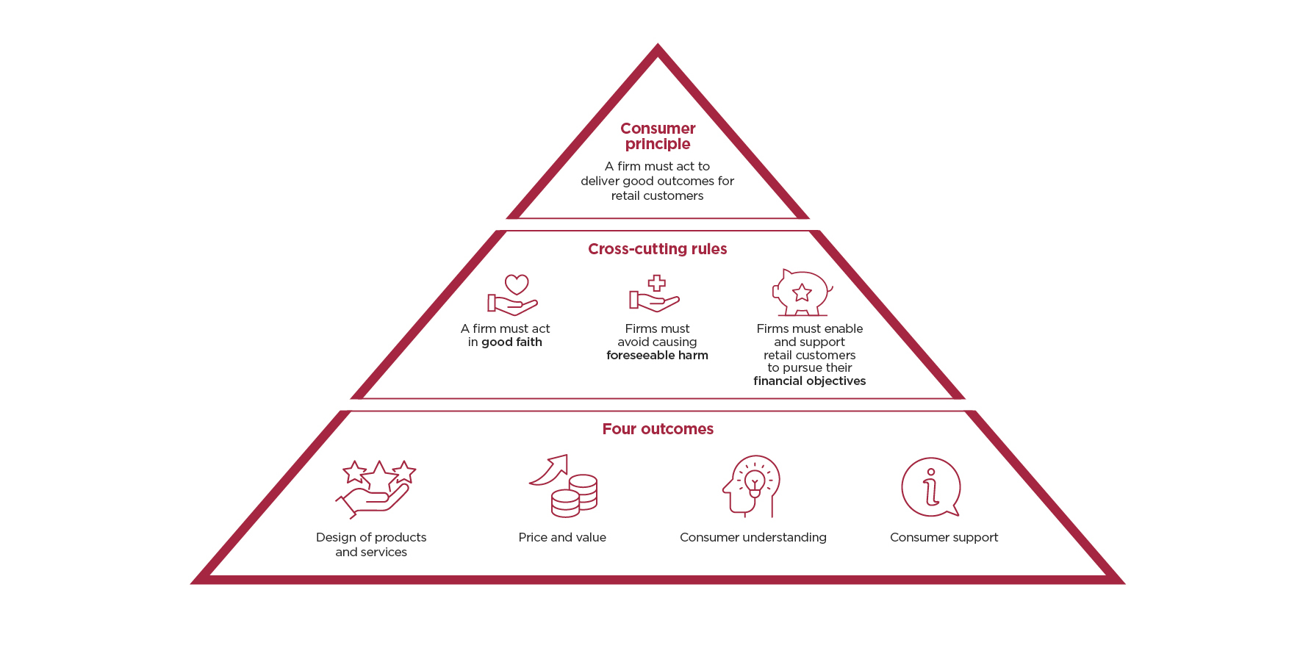
The rules require firms to consider the needs, characteristics and objectives of their customers – including those with characteristics of vulnerability – and how they behave, at every stage of the client journey. As well as acting to deliver good client outcomes, firms will need to understand and evidence whether those outcomes are being met.
Whilst the implementation is for 31 July 2023, the FCA requires firms to have a plan in place by the end of October 2022.
The purpose of this document is to help you to assess how you are meeting the cross-cutting rules and consumer outcomes of the Consumer Duty at the moment and what evidence you have to support this.
If there are any areas which need to be improved, then action will be required. These areas will be identified, allocating ownership and timescales for their completion, meaning that you can be ready for when the Consumer Duty is implemented.
This gap analysis identifies key risks to your practice which specifically focuses on the Consumer Duty.
This forms the basis of your implementation plan in identifying if you are delivering good outcomes for all clients. This gap analysis will identify key risk areas and also provide you with the opportunity to demonstrate how you feel you are meeting your regulatory obligations.
Where action is required, this will be recorded in the action plan at the end of the document and assigned to a relevant individual for implementation. This gap analysis will only be completed when agreed and signed off by senior manager(s) and/ or the Board (if applicable). You should then complete ‘Interim Reviews’ to clearly outline your project work and firm progression.
Please find below 10 questions the FCA has recently published to help firms check they are on track to meet their Consumer Duty principles.
10 key questions for firms to consider:
- Are you satisfied your products and services are well designed to meet the needs of consumers in the target market, and perform as expected? What testing has been conducted?
- Do your products or services have features that could risk harm for groups of customers with characteristics of vulnerability? If so, what changes to the design of your products and services are you making?
- What action have you taken as a result of your fair value assessments, and how are you ensuring this action is effective in improving consumer outcomes?
- What data, MI and other intelligence are you using to monitor the fair value of your products and services on an ongoing basis?
- How are you testing the effectiveness of your communications? How are you acting on these results?
- How do you adapt your communications to meet the needs of customers with characteristics of vulnerability, and how do you know these adaptions are effective?
- What assessment have you made about whether your customer support is meeting the needs of customers with characteristics of vulnerability? What data, MI and customer feedback is being used to support this assessment?
- How have you satisfied yourself that the quality and availability of any post-sale support you have is as good as your pre-sale support?
- Do individuals throughout your firm – including those in control and support functions – understand their role and responsibility in delivering the Duty?
- Have you identified the key risks to your ability to deliver good outcomes to customers and put appropriate mitigants in place?

The Gap analysis
Client engagement and communications
Areas to Consider | Firm’s Observations | Action Required  Yes/No | Consumer Duty Group
How do you target clients? Please add commentary on the relationships and connections you have. Think about your financial promotions. Who is responsible? What is the process for approval? Are they clear, fair and not misleading? |  |  | Products & Services
Do you have any professional introducers in place? If so, what business is being introduced? And by what source? |  |  | Products & Services
What due diligence do you undertake on your introducers? Do you have formal procedures for appointing any new introducers? Formal checklists in place? |  |  | Products & Services
Do you refer any business to other firms? Is this formalised? Agreements in place? |  |  | Products & Services
Do you review the client experience when business is referred away? Reputational risk being considered? |  |  | Products & Services
If applicable, do you use a packager for any mortgage business? If so, please list the due diligence you have undertaken. |  |  | Products & Services
Do you issue financial promotions, and if so, how do you ensure they are clear, fair and not misleading and suitable for the target audience? |  |  | Consumer Understanding
Do you offer discovery meetings with clients before any services are initiated? Complimentary consultations? |  |  | Consumer Understanding
How do you communicate with clients? Outline your method for delivering material. |  |  | Consumer Understanding
Are all communications tailored to the client? Who is responsible for checking all communications? |  |  | Consumer Understanding

Advisory practice/Price and value
Areas to Consider | Firm’s Observations | Action Required  Yes/No | Consumer Duty Group
Have you conducted a Fair Value Assessment? If yes, what was considered? What action is needed, if any? |  |  | Price & Value
In relation to your products and services, are the charging structures consistent within the practice? If there are different charging structures, please outline why. |  |  | Price & Value
How do you distribute products/services to clients? (for example do you undertake any of the following; advised, non-advised, execution only, website material, etc)? |  |  | Products & Services
Have you completed your PROD assessments? When was this last reviewed? We would recommend this is included in your CIP document. Does this include all products?  It is important to remember that the FCA sees the adviser’s role in product governance as: ‘the adviser can often also have the clearest oversight of the customer’s overall position and an overview of the total proposition. In this instance, it should consider the overall outcomes being delivered for the customer.’  Advisers may prioritise information in product governance literature according to how relevant it is to overall outcomes. |  |  | Products & Services
How do you charge for your initial advice? (percentage, hourly fees, hourly rates) |  |  | Price & Value
Do you have a minimum charge or investment/loan amount? If so, please outline this. |  |  | Price & Value
Do you have a cap on your charges? Is there a senior manager approval needed if adviser exceeds this limit?  Do you have a Fee Divergence Register to record this? |  |  | Price & Value
How and when in the advisory process do you issue regulatory information to the client? |  |  | Consumer Understanding
At what stage do you discuss your initial costs and services information within the advisory process. How do clients agree to the charges? Separate Fee Engagement document used? It is recommended all fees are agreed in monetary terms. |  |  | Consumer Understanding
When was the last time you reviewed your Disclosure Documents? Do all advisers issue the same documentation? |  |  | Consumer Understanding
Did this assessment review the content to ensure clear and engaging for new clients? It is recommended that you seek independent review and feedback of your documents. |  |  | Consumer Understanding
What steps do you take to ensure your clients understand both the regulatory information and your costs and services (client feedback)? |  |  | Consumer Understanding
How do you ensure recommendations are issued in a timely manner? Is there a company policy for number of working days you issue a Suitability Report? |  |  | Consumer Understanding
Do your advisers understand the products they are recommending? How? Documented? |  |  | Consumer Understanding
If your firm recommends platforms, how do you ensure clients have the appropriate IT knowledge to be able to access and understand the information? |  |  | Consumer Understanding
Do you operate a back-office system? Have you undertaken due diligence on the third party? |  |  | Consumer Support
Do you offer a client portal for clients to upload sensitive information? |  |  | Products & Service
Where you assist clients with additional borrowing, do your charges reflect the service provided? Do advisers question the client about the purpose for the additional borrowing? |  |  | Price & Value
If additional borrowing, do you research and ask how many times the client has undertaken this in the past? Repeat debt consolidation? |  |  | Products & Services
If applicable, how do you exhaust all prime lending options prior to recommending a sub-prime lender? |  |  | Products & Services
If dealing with clients that require debt consolidation, how do discuss the pros and cons of turning unsecured debt into secured debt? |  |  | Consumer Understanding
Do any mortgage brokers charge a consistent fee in the business? If not, explain why? |  |  | Price & Value
Do advisers complete a budget planner? Do advisers question the outgoings and consider the cost-of-living crisis? |  |  | Price & Value
How do you avoid foreseeable harm in the advisory process? |  |  | All
Can you evidence that ‘greenwashing’ does not apply to a sustainable and values-based (including ESG) fund recommendation? |  |  | Products & Services
How do you ascertain a client’s sustainable and values-based (including ESG)/ethical understanding and concerns? |  |  | Products & Services
Have advisers received appropriate training on sustainable and values-based (including ESG) investments? |  |  | Products & Services

Evidencing good client outcomes
Areas to Consider | Firm’s Observations | Action Required  Yes/No | Consumer Duty Group
Do advisers complete a CPD action plan at the commencement of the year? This should be created to outline their training goals/needs for the forthcoming year. |  |  | Consumer Support
Does each adviser/paraplanner complete a regular programme of relevant CPD training throughout the year? Please outline the systems used. |  |  | Consumer Support
Do you create additional development plans throughout the year? |  |  | Consumer Support
Do you operate a centralised investment/retirement process? Has this been formalised? Are all relevant staff aware of this document? |  |  | Products & Services
Do you apply a consistent approach throughout when making recommendations? |  |  | Products & Services
Do existing clients receive the same service as new clients? |  |  | Products & Services
How do you ensure product recommendations offer fair value? |  |  | Products & Services
How do you ensure any ancillary service providers (e.g. platform, DFM, etc) offers good value to clients? |  |  | Products & Services
How do you ensure clients understand the products they purchase? |  |  | Consumer Understanding
How do you ensure clients understand the risks and any disadvantages of the products they purchase? |  |  | Consumer Understanding
Are independent file checks carried out? |  |  | All
Do you review the quality of file checks and ensure any trends are discussed as a group to ensure they are not repeated? Is this documented? |  |  | All
If applicable, how do mortgage advisers understand lender criteria? |  |  | Products & Services
What is the process for disengaging clients? |  |  | Consumer Support
What is your process for the holdings of any deceased clients? |  |  | Consumer Support
Can you evidence that you have been proactive in avoiding foreseeable harm to clients? E.g. Russia’s invasion of Ukraine, did you communicate with clients about portfolios, reassurance etc? |  |  | Consumer Support

Vulnerable clients
Areas to Consider | Firm’s Observations | Action Required  Yes/No | Consumer Duty Group
Do you hold a formal vulnerable persons policy? Has this been circulated to staff? |  |  | Consumer Support
Have all relevant staff received training in this area? |  |  | Consumer Support
Do you deal with a vulnerable demographic client bank? If so, what additional measures/steps do you undertake? |  |  | Consumer Support
Do you promote products whose target market can be for individuals that could be deemed vulnerable? |  |  | Consumer Support
Have you adapted any process to meet the needs of vulnerability? i.e. family/friend attend meetings? Adviser to be accompanied by another adviser or senior manager. Repeat back to me exercise etc? |  |  | Consumer Support
Do you review the outcomes for your vulnerable persons? |  |  | Consumer Support
Do you discuss the importance of holding/appointing a Power of Attorney? |  |  | Consumer Support
Are you including questioning around the impact of the cost-of-living crisis’? Advisers to ensure they query amounts for budget planner purposes. |  |  | Consumer Support

Ongoing advisory process
Areas to Consider | Firm’s Observations | Action Required  Yes/No | Consumer Duty Group
Do you offer ongoing services to consumers? Outline the different tiers you offer. |  |  | Products & Services
At what stage in the advisory process do you agree this ongoing service? |  |  | Price & Value
How do you charge for your range of ongoing services? Percentage, fixed project fee, hourly rate) |  |  | Price & Value
How do you ensure the ongoing services (or level of a service) is appropriate and tangible for clients? |  |  | Price & Value
Do you initiate contact when reviews are due? How? Diary system? |  |  | Consumer Support
Do you monitor ongoing client engagement? |  |  | Consumer Support
How do you deal with consumers that do not engage? Do you have a non-engaging client process document? |  |  | Consumer Support
Do you issue client surveys, or other means of requesting client feedback? If so, please outline the method. Do you monitor the responses and action salient feedback? |  |  | Consumer Understanding /Consumer Support
Do you seek feedback from staff?  How is this recorded? |  |  | Consumer Support
If applicable, do you contact clients before the expiration of their fixed/tracker rate mortgage? Outline the method adopted. |  |  | Consumer Support

Management
Areas to Consider | Firm’s Observations | Action Required  Yes/No | Consumer Duty Group
Do you have a formal Training & Competence regime in place? Is this formalised and accurate for your firm? |  |  | All
Do you produce KPIs for each adviser? Please comment on frequency and process. |  |  | All
Do you produce company KPIs to identify any trends as a business? Are these discussed at a senior/ Board level? |  |  | All
Have all staff completed the Conduct Rules training? |  |  | All
Do you monitor emerging risks that can affect the firm and/or its clients? |  |  | All
Are Certified Persons subject to Credit Report reviews? If so, please outline the frequency? |  |  | All
Are back-office staff subject to appraisals? Development Plans? Training Plans? etc. |  |  | Consumer Support
How do you deal with, and learn from, complaints? Root cause analysis, group training etc. |  |  | Consumer Support
Do you have ARs within the business? |  |  | All
If so, do you have formal agreements in place? |  |  | All
Are any ARs subject to the same supervision as the principal advisers? If not, why? |  |  | All

You have now completed the gap analysis. Please record any gaps identified in the below table. It is important that you now spend time discussing the risk as a company and document how you intend to rectify the shortfall(s). It is recommended that you record and document all progression as a group i.e. team meetings, board meetings etc. Please refer to the Interim Review Document to assist with demonstrating your progress.

Action Plan
Gaps Identified | Actions To Be Taken by the Firm | Senior Manager Responsible | Date Completed

It is recommended that you undertake interim reviews to ensure there is a clear audit trail of the continued project work that your firm conducts. These reviews need to be fully documented and to record how gaps are being rectified. You should ensure reviews are presented to senior management and/or the board and that there is an audit trail that any decisions are being signed off by the senior management/board.

Next review scheduled for: [insert next review date]

